#
# 20210409
#
https://tinkoff.slack.com/archives/GHN18GB2M/p1617967842040600
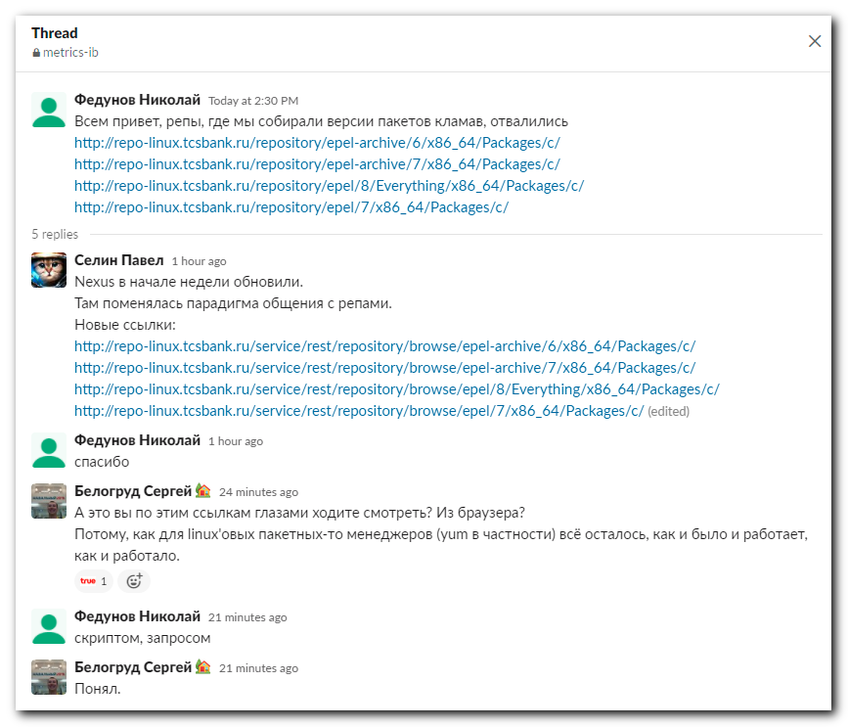

http://repo-linux.tcsbank.ru/service/rest/repository/browse/epel-archive/6/x86_64/Packages/c/
http://repo-linux.tcsbank.ru/service/rest/repository/browse/epel-archive/7/x86_64/Packages/c/
http://repo-linux.tcsbank.ru/service/rest/repository/browse/epel/8/Everything/x86_64/Packages/c/
http://repo-linux.tcsbank.ru/service/rest/repository/browse/epel/7/x86_64/Packages/c/

http://m1-nexus01p.tcsbank.ru:8081/#browse/browse:epel
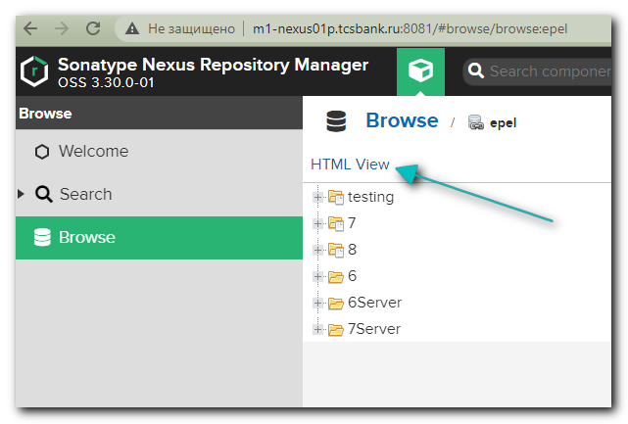

http://m1-nexus01p.tcsbank.ru:8081/service/rest/repository/browse/epel/7/x86_64/Packages/c/
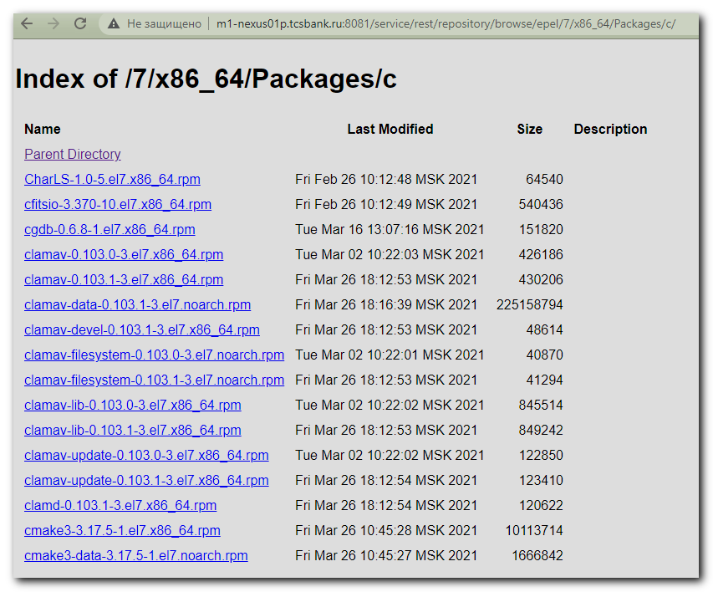

#
# Added section (I think Selin Pavel added this section) allow view repositories via web browser.
#
[root@ds-repo01 ~]# cat /etc/nginx/conf.d/default.conf
...
location /repository {
proxy_pass http://m1-nexus01p.tcsbank.ru:8081/repository;
proxy_set_header X-Forwarded-For $proxy_add_x_forwarded_for;
proxy_set_header X-Real-IP $remote_addr;
proxy_set_header Host $host;
}
location /service {
proxy_pass http://m1-nexus01p.tcsbank.ru:8081/service;
proxy_set_header X-Forwarded-For $proxy_add_x_forwarded_for;
proxy_set_header X-Real-IP $remote_addr;
proxy_set_header Host $host;
}
...

http://repo-linux.tcsbank.ru/service/rest/repository/browse/epel/7/x86_64/Packages/c/
